SCCA ITR PONY CAR CLASSING PROPOSAL

As of this writing SCCA’s Improved Touring R class has been in place for almost one year. The class has had a positive impact on Improved Touring (IT) as many popular, higher power sports cars and sedans that were previously not classed in IT can now participate under the IT rules set. For only being in existence for on year, ITR participation has been significant, and is growing (compared to say, for example, BP and DP). There are a significant number of ITR cars racing and many more under construction. Cars that are known to fall into these two categories include the BMW Z3 2.8, BMW 325, BMW 328, BMW 330, Nissan 300zx, Honda S2000, Acura Integra Type R, Porsche 944 S2, Porsche 968, Porsche Boxster, and the Toyota Celica GTS.
Thus, it appears ITR has been well received by the majority of IT racers and the momentum for the class is growing.

However, there is a void in ITR with respect to “V8 Pony Cars” – V8 Ford Mustangs and V8 Chevrolet Camaros are notably absent. We believe that filling this void will simply add to the momentum that ITR is experiencing.

Certain popular, lower powered versions of these cars can fit into ITR easily and there is a distinct need for them in the class. The reasons we believe support their inclusion are (at least) the following:

- They fit into ITR based on IT horsepower production.
- They fit into ITR based on torque, but will need weight modifier for torque/displacement. We propose 100 lbs.
- Their inclusion provides a low-cost (IT) rules set to race a modern domestic fuel injected V8.
- Their inclusion provides an alternative to costly SCCA National American Sedan racing for domestic V8s.
- Their inclusion may attract racers from NASA which does provide classes for modern fuel injected domestic V8s and a similar class for AS-type cars.
- An informal internet survey has shown that the cars already have a large amount of support in the IT community among racers who would like to build a V8 ITR Pony Car.

Horsepower
The original grouping of ITR cars were classed by weight and this was based on horsepower, chassis/suspension, brakes, and other factors. Clearly horsepower plays (and should play) a fundamental role in the classification process.

The standard ITR power classification would be made based on an IT modifier for power increase and a target power to weight ratio for the ITR class. A stock 1994/1995 Mustang GT (A target car we’ll use as an example in the discussion) has 215hp, the standard IT modifier is 25%, and the target power to weight ratio is 11.25 to 1. Using the standard formula would result in a weight classification of:

215hp x 1.25 x 11.25 = 3023 lbs

If a plot is made of classed ITR car weights versus stock horsepower for the upper echelon horsepower cars in the class, the following plot will be observed (Figure 1).
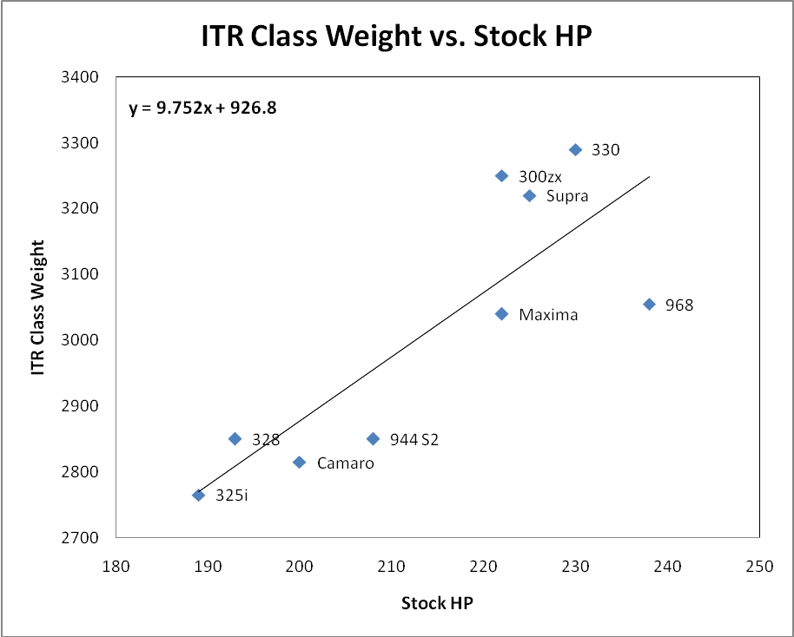
Figure 1

A linear regression analysis can be performed on the dataset and it results in a fairly linear relationship between stock flywheel horsepower and ITR class weight. The regression result (IT Weight = 9.95 * (Stock HP) + 890.8) can be used to calculate a rough estimate for ITR class weight for any potential ITR candidate car.

In the case of a 1994/1995 Mustang GT with 215hp stock we would arrive at an estimated class weight of approximately 3023 lbs without any subjective adders or subtractors. This is in agreement with the process IT weight of 3023 lbs.

IT Trim Horsepower Gains
Naturally careful estimates have to be made of how much of a horsepower gain will be realized with a particular engine in IT trim. A standard percent gain is often quoted at 25% and in many cases this estimate seems to fit well. However it may be necessary to modify this gain based on an individual engine configuration from the factory. If one were to look at expected horsepower gains for some ITR candidates the following data chart can be produced:

Car | IT Trim HP | Classed Weight
BMW 325i | 240 | 2765
BMW 328 | 250 | 2850
Camaro | 250 | 2815
944 S2 | 250 | 2850
Maxima | 275 | 3040
300zx | 280 | 3250
Supra | 280 | 3220
BMW 330 | 275 | 3290
968 | 265 | 3055
Some of these expected IT horsepower figures are simply 25% gains with rounding. Others are estimates based on empirical data. The following plot shows ITR class weight versus predicted IT trim horsepower, again a very linear relationship is shown. In Figure 2 the horsepower figure is shown as the first data label followed by the car model.

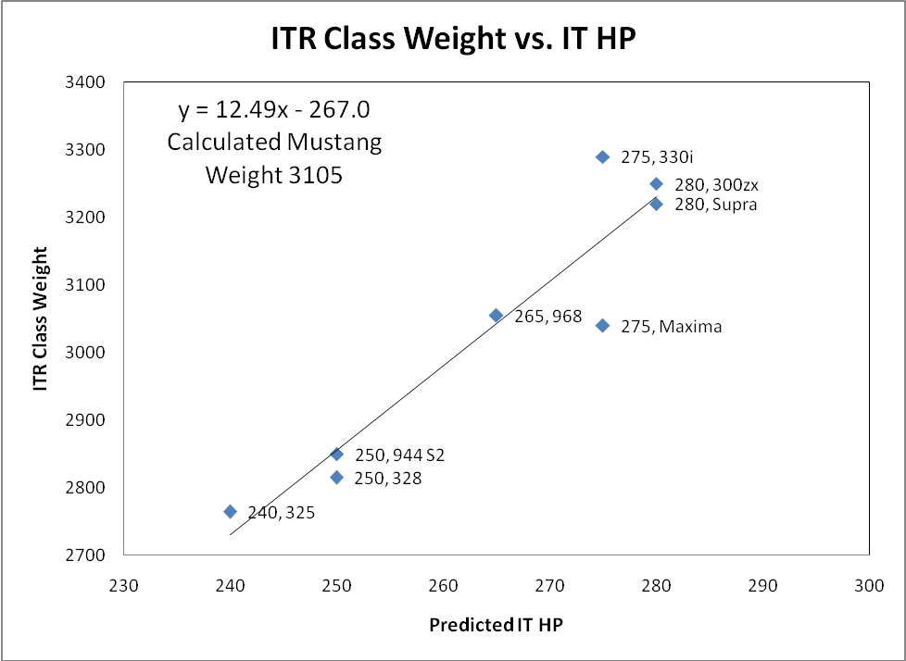
Figure 2

The 5L 1994/1995 Mustang GT is commonly known to be able to produce approximately 250 to 275 flywheel horsepower in a rough “street” approximation of IT trim, or up to a 25% increase. This seemingly low result based on displacement is due to a number of factors: a pushrod two valve per cylinder design, an undersized mass air flow sensor, an undersized throttle body, a special intake for the low 1994/1995 hood lines that is extremely constricted compared to 1985-1993 manifolds, and Ford E7 head castings with a poor exhaust port design which cannot be rectified in IT trim.

The linear regression analysis performed for the ITR class weight versus predicted IT horsepower returns an equation of (IT Weight = 12.49 * (Predicted IT HP) – 276.0). Assuming the 1994/1995 Mustang GT can produce 270 hp we have an estimated ITR weight for the car of 3105 lbs. This figure is in close agreement with the 3023 lbs predicted using the stock flywheel horsepower model and the 3023 lbs suggested by the IT process.

These three analysis methods show the 1994/1995 Mustang GT can fit into ITR with respect to horsepower. Indeed, the 5L V8 in the Mustang is simply an air pump and with its’ pushrod two valve per cylinder design, a relatively crude one at that.

Torque
Horsepower alone does not determine the suitability of inclusion for a car into ITR. Another figure of merit that must be evaluated is torque production. The 1994/1995 Mustang GT has a absolute torque advantage over other cars in ITR.

Car | Stock Torque | Torque / Liter
BMW 325i | 181 | 72
BMW 328 | 207 | 74
Camaro V6* | 225 | 59
944 S2 | 207 | 69
300zx | 198 | 66
Supra | 220 | 73
BMW 330 | 215 | 72
968 | 225 | 75
Mustang* | 285 | 57

*Two valve motors have significantly less torque per liter displacement than four valve designs.

Somewhat surprisingly a plot of ITR class weight versus stock torque does not produce a linear relationship at all, The R² value for the regression model is less than 0.07 which reflects almost zero correlation. It would appear that a relatively subjective process was used when considering torque production in respect to classed ITR weight. Be that as it may, we would strongly suggest that a 1994/1995 Mustang GT receive a weight modification based on displacement of the engine and torque production. Figure 3 contains the ITR weight versus torque data.

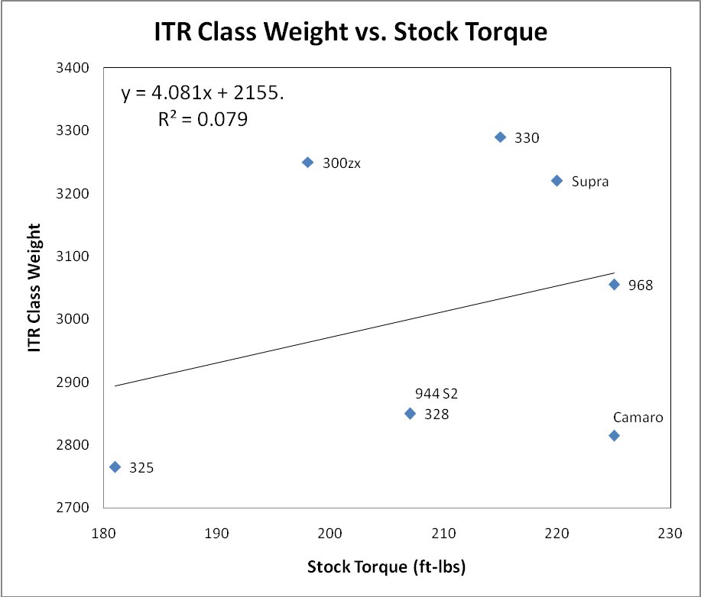
Figure 3

It is believed that a stock 1994/1995 Mustang GT generally produces around 235 to 245 ft-lbs of rear wheel torque on a Dynojet dynometer. This will result in approximately 290 ft-lbs of rear wheel torque if one assumes a standard IT gain of 25%. In reality the gain is actually less than 25% with “street” IT-like builds producing in the neighborhood of 275-280 ft-lbs. The car is highly optimized for torque production from the factory due to small volume ports, high port velocity at low RPM, and small cam thus 25% improvements are hard to realize.

The point is that the 1994/1995 Mustang GT has torque capacity that is certainly within the performance envelope of ITR and should not be discounted because of class leading torque figures.

Other V8 Mustangs
The discussion thus far has focused on the 1994/1995 Mustang GT with a 5.0L OHV 2 valve per cylinder design. The car fits into the ITR framework quite well. However there are other V8 Pony cars that could fit into the class – earlier V8 Ford Mustangs and 3rd Generation GM V8 Camaros and Firebirds (3rd Gen F-Bodies).

The earlier Fox boded Mustang V8s, from 1982-1993, had a large variety of horsepower ratings due to changes in induction and cams over the years. The lowest horsepower model in this range is 165hp and the highest is 225hp. The cars are cheap and plentiful and, like the 1994/1995 Mustang GT, could be classed in ITR at approximately the same weight. But, none of these cars had rear disc brakes and each one would almost require a separate spec line in the GCR due to induction differences. For example the following is an incomplete list of horsepower and induction based on year:

Year | Horsepower | Induction
1982 | 165 | 2 bbl carb
1983-1984 | 175 | 4 bbl carb
1985 | 210 | 4bbl, roller cam
1986 | 200 | EFI, Speed Density
1987 | 225 | EFI, Speed Density
1988 (49 State) | 225 | EFI, Speed Density
1988 CA | 225 | EFI, Mass Air Flow
1989-1993 | 225 | EFI Mass Air Flow

The cars would need to be specified at the same weight as the 1994/1995 V8 Mustangs, or, possibly at a higher weight. The 225 hp cars have better intakes and cams than the 1994/1995 V8 Mustangs and can produce slightly more power in IT trim.

If the cars were to be included we could simplify the years and models to the following:
Year | Induction
1989-1993 Mustang GT | EFI, MAF

This would provide the “best” Fox 3 ITR platform with the most power, torque, and strongest rear end. They have brakes that are inferior to the 1994/1995 cars, but they can produce more power than the 1994/1995 V8 Mustangs.

GM Pony Cars – Camaro and Firebird
GM has produced 3rd Gen F Bodies that fit well into the ITR class. The 1987 through 1992 LB9 powered 3rd Gen F Bodies with the five speed manual transmission were rated:

1987 LB9 215hp@4400 / 295lbft@3200
1988 LB9 220hp@4400 / 290lbft@3200
1989 LB9 230hp@4600 / 300lbft@3200
1990 LB9 230hp@4400 / 300lbft@3200
1991 LB9 230hp@4200 / 300lbft@3200
1992 LB9 230hp@4200 / 300lbft@3200

The 3rd Gen F Bodies also have four wheel disc brakes and a solid rear axle, just as the 1994/1995 Mustang GT does. Power gains for these motors will be somewhat hampered by camshaft, but even if a 25% gain is assumed they can still fit within the confines of ITR.

American Sedan
When ITR was being developed by the ad hoc ITR committee the V8 Mustangs and Camaros were discussed. Some people felt the car fit the ITR classing process and should be included. Others had objections against the cars, one of them being that they already had a place to race in American Sedan (AS).

Any investigation at all into the AS rule set will show that AS prep is far and above IT prep. Among the fundamental differences that alienate many IT racers are some of the AS prep details: the mandatory use of carburetors, expensive advanced engine preparation including alternative cylinder heads, open cams and valve train, expensive car preparation beyond IT builds, alternative driveline components, low mean time between failure on many parts, and so on. In sum, an AS car is very different from an IT prepped Mustang and Camaro, and we feel that there will be little if any crossover between racers interested in one rule set or the other.

Additionally, we firmly know there are racers who would prefer to race their pony cars against different makes and models, and with a more stable and restricted ruleset than American Sedan. Club track days are full of Mustangs and Camaros running non-competitive track day events with full cages and other race prep. Many of these cars would be, in our view, likely to cross over to IT if given the opportunity to do so.

Improved Touring Forum Support
The ITR V8 Mustang proposal has been aired on the internet forum for Improved Touring located at http://itforum.improvedtouring.com/forums/. The proposal has generated interest among racers and currently there are ten racers who would build a V8 Pony Car if classified. These racers do not have any interest in the AS class.

ITR Classification Recommendations
The recommendations are based upon the following criteria for the V8 Pony Cars:

- Horsepower output that is near the top of the class. Low RPM limit.
- Torque production that will be the highest in class by 10-15%. The cars will need a weight modifier beyond process weight.
- Brakes that are inferior to the majority of cars in the class (even with the four wheel disc brakes on the Camaros). Swept area per ton will be in the bottom 10% of the class if the car weighs near 3200 lbs.
- Solid rear axle on all of the proposed cars (I am aware that the ITAC has not previously used a modifier for this “feature”, however, I think that would be an error in judgment on a 240-250 rwhp car in a race class full of independent rear suspensions)

Shown below is the process weight at a power to weight ratio of 11.25:1 for each car in the proposal. Following the process weight is our recommended class weight with a subjective torque modifier of 100 lbs added to the process weight.

Car | IT Process | Recommended Weight
94/95 GT | 3023 | 3120
89-93 GT | 3164 | 3260
F Body | 3234 | 3330

Classifications
- 1994/1995 Ford Mustang GT at 3120 lbs (exclude Cobra).
- 1989-1993 Ford Mustang GT and LX 5.0L at 3260 lbs (Exclude Cobra)
- 1987-1992 Chevrolet Camaro at 3330 lbs (exclude 1LE & BC4 Package).
- 1987-1992 Pontiac Firebird at 3330 lbs (exclude 1LE & BC4 Package).

Summary
Classification of V8 Pony Cars into ITR will meet the needs of IT racers and expand the ITR class. For the first time a low-cost SCCA class will be available for domestic Pony Car enthusiasts to road race their favorite vehicles.

Authors
Ron Earp, SCCA Member 345404
Jeff Young, SCCA Member 304971

