HVAC Blower Fan Relay Retrofit Supplement to Original Bulletin
It has come to our attention that some harness kits may come from the factory with a Tyco brand relay not compatible with the original wiring.
The harness can be made compatible by simply switching the 86 and 30 terminals for each relay.
If you received this harness, it has Tyco brand relay and you are experience a problem of no medium and high-speed blower fan, the directions below will explain how to make the harness compatible with this relay.

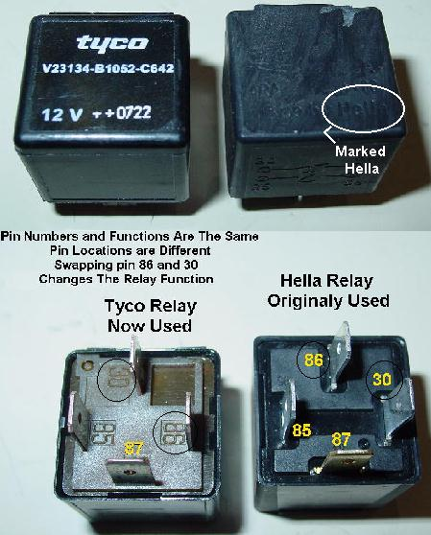
Fig.1a Relay Identification

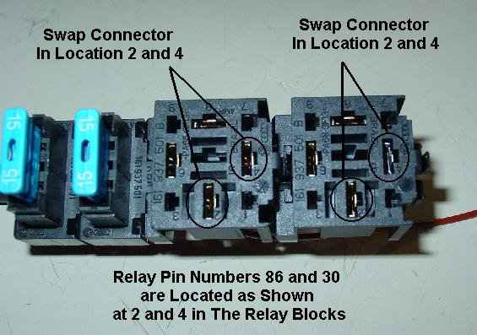
Fig. 2a Location of Connector to Swap

- Identify that your harness has Tyco relays. If Hella relay are present the harness is wired correctly. Figure 1a illustrates the two different relays. Also shown if the pin number location on the relays. This difference changes the relay function and prevents them from activating.
- To change the wiring for the Tyco relays, pin 86 and 30 must be swapped at the relay holder. Locations of these connectors are identified as 2 and 4 on the holder. (See Figure 2a) Wires in location 2 (moving to 4) must correspond with pin 86 on the relays. This is the brown ground wire that loops together. Wires in location 4 (moving to 2) must correspond with pin 30 on the relays. This is the red supply wire that also loops together.
- To release the connector from the relay holders, insert a flat tool like a terminal release tool or a small screwdriver into the small slot next to the terminal. (See figure 3a) Push the tool towards the connector to release the clip while pulling the connector out from the bottom.
- Swap the connectors around from 2 to 4 in each relay holder. See figure 4a for details of the bottom of the relay holders. You may need to bend the clip back out so the connector will hold.

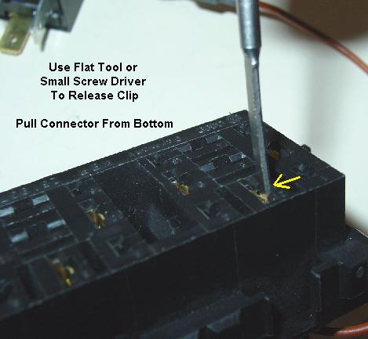
Fig. 3a Releasing the Connectors in the Relay Holder

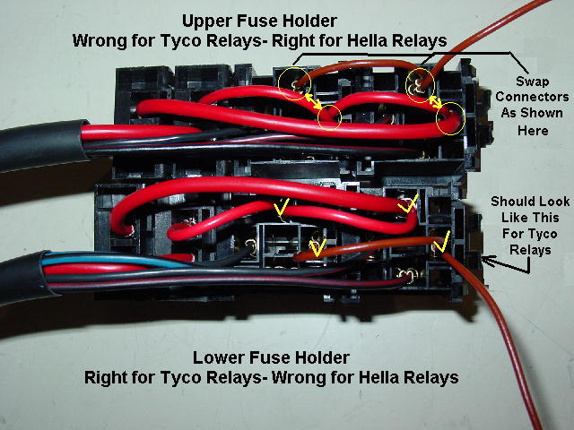
Fig. 4a Bottom View Relay Holder

