HVAC Blower Fan Relay Retrofit

Note: Make sure your HVAC blower system has not had the run-on repair using a diode installed as in bulletin 0601GTB. If you have this, it must be reversed and the Hi-Tech fixed implemented. You can tell this by examining the Fuse/Relay block. If the relay shown below is removed the Hi-Tech fix is used.
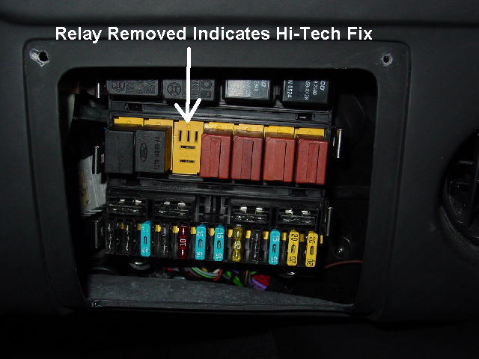

This bulletin will show how to install the Superformace GT40 Blower Fan Relay Retrofit. This added harness has been designed to eliminate a high amp draw on the blower switch. This is being done to eliminate concerns of future switch failure problems.
You will receive a harness to be installed. The hardware needed is not included by Hi-Tech or Superformance. Hardware needed includes two 5mm bolts at least 10mm long, two 5mm nuts and 45mm washers. You will also need one 5/16” drive self-tapping screw, one zip-tie and two 2 ½” long pieces of 3/8” shrink tube.

Installation of Harness
- Disconnect the battery before beginning. Remove the fuse panel cover and check for the Hi-Tech run on fix as mentioned on the previous page.
- Remove the center console riser under the center of the dash. Remove the ignition switch if it is located in this area.
- Remove the screws holding the main switch panel in the center of the dash. (Fig.1)
- If your ignition switch is on the left side of the dash, remove the switch panel below it. (Fig.2) If your ignition switch is in the center below the dash it is not necessary to remove this panel.
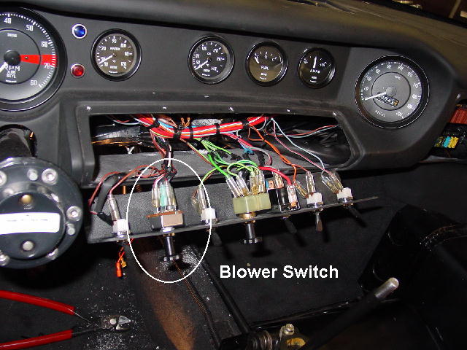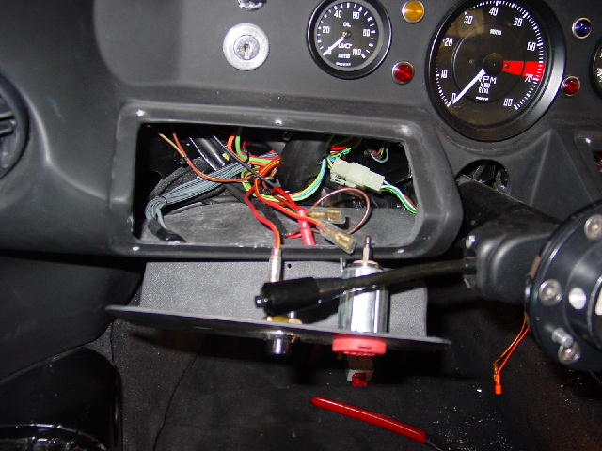
Fig. 1 Fig.2

- Use the template, figure 4 from the next page. Lay this under the dash with the long side toward the end at the steering column. Line it up along the edge of the dash and mark the holes. See fig. 3 Drill two 7/64” holes being careful not to damage any of the wires.

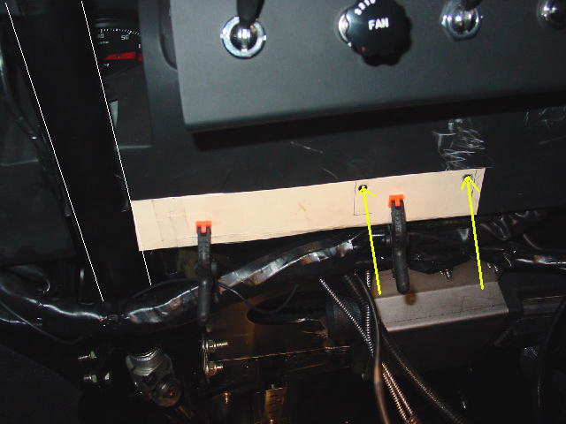 Fig.3
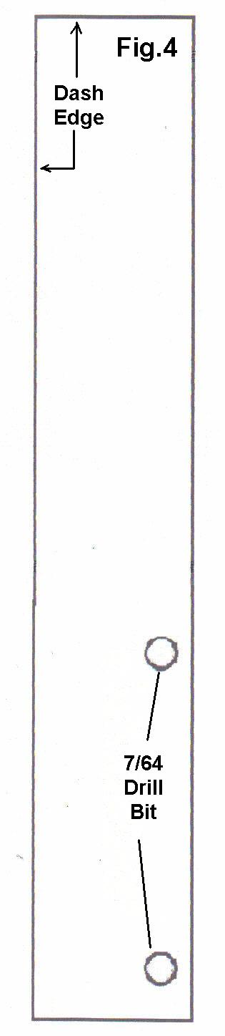
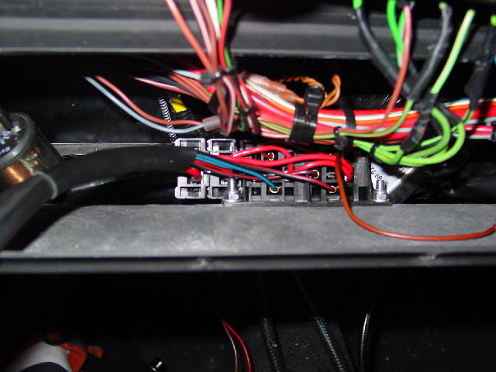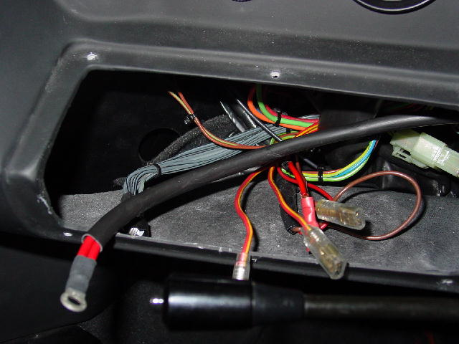
Fig.5 Fig.6

- Install the fuse and relay panel using two 5 mm bolts, washers and nuts. The relays and fuse should protrude from the rear of the dash slightly and the back of the panel will face out the opening as in figure 5.
- If your ignition switch is on the left side of the panel, run the double red wire from the fuse panel over the steering column to the switch opening on the left side of the dash. (Fig.6)
- If your ignition switch is under the dash in the center, run it under to this location as in figure 7.

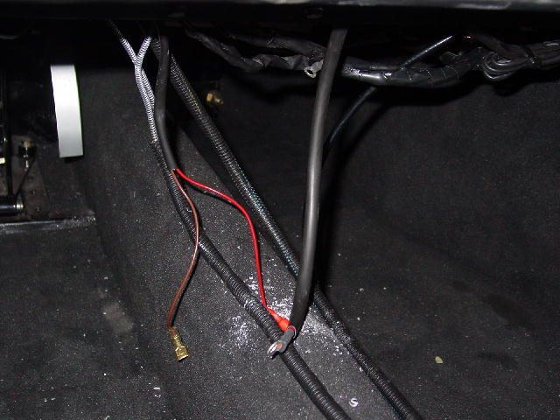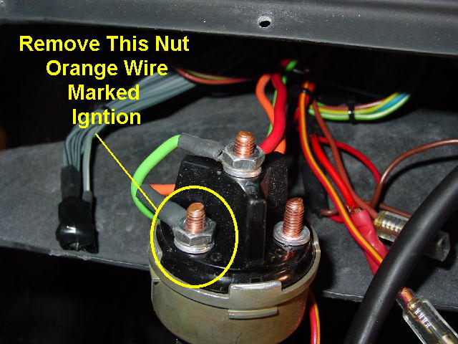
Fig.7 Fig.8

- Remove the ignition switch if not already done. Find the terminal containing the orange wire that is marker IGN. (Fig.8)
- Attach the double red wire to this post. (Fig.9)
- Find the Brown wire from the panel and attach it to the steel chassis using a self-taping screw. The steel chassi is immediately ahead of the dash when viewed from underneath. Be sure to clean the paint off so there is a good ground connection. (Fig.10)

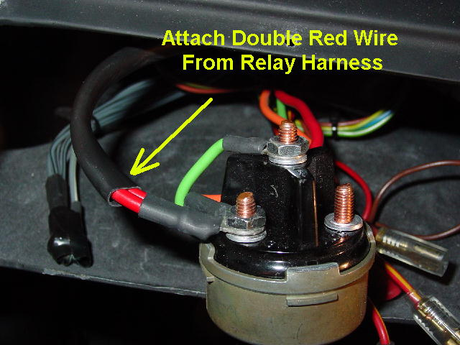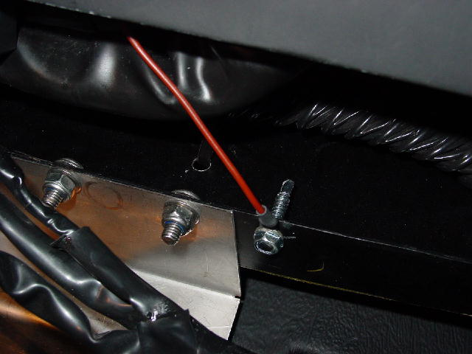
Fig.9 Fig.10
- Locate the blower switch on the long panel. Figure 1 shows the location.

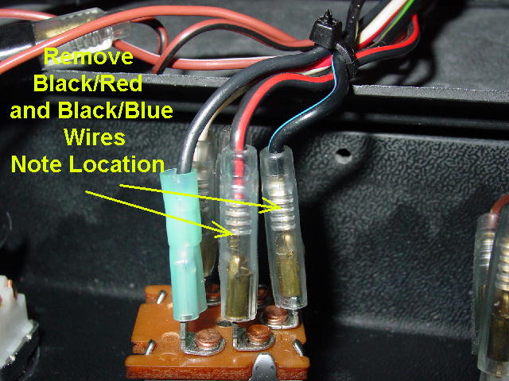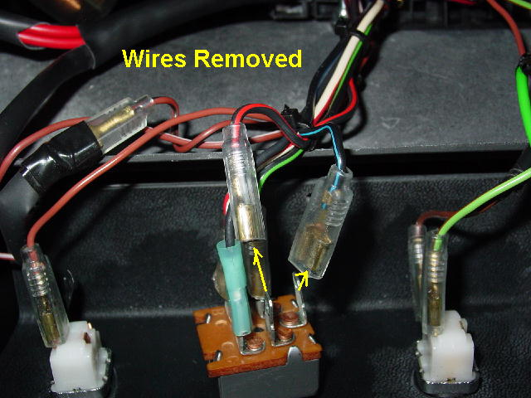
Fig. 11 Fig. 12
- Remove the Black/Blue wire and the Black/Red wire. Note their location on the switch. Fig. 11-12
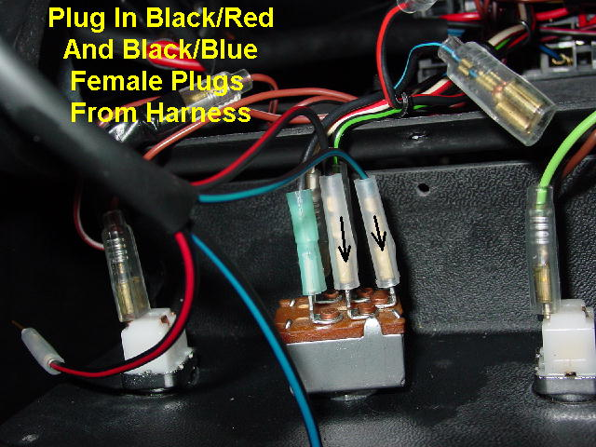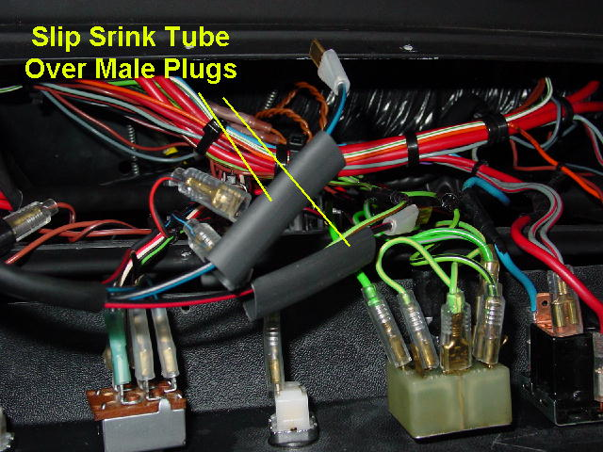
Fig.13 Fig.14
- Plug the female Black/Blue wire and the Black/Red from the panel harness into the switch matching the colors to the same location as the removed wires. (Fig.13)
- Slide the 3/8” shrink tube over the remaining two male plugs from the panel harness. (Fig.14)

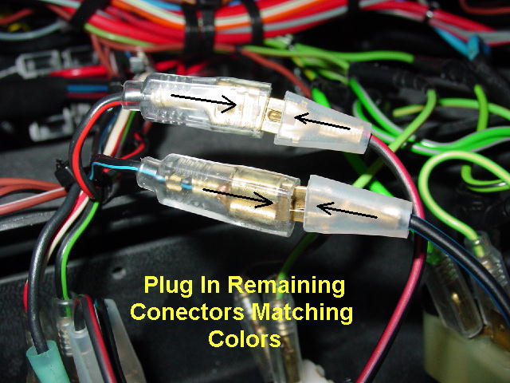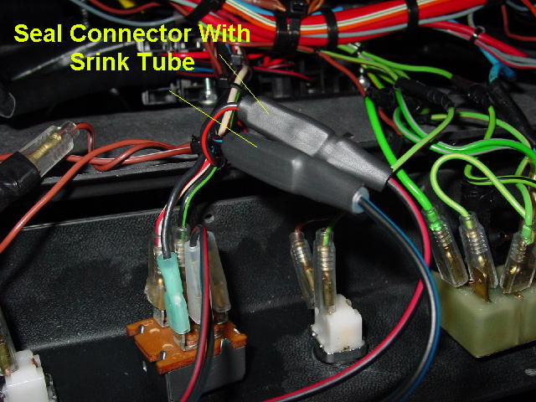
Fig. 15 Fig.16
- Plug the remaining harness male wires into the two female plugs removed from the switch. Make sure they fit together tightly, if not squeeze the female plug with pliers to tighten.
- Pull the shrink tube over the plugs and seal them together by heating as in figure 16.

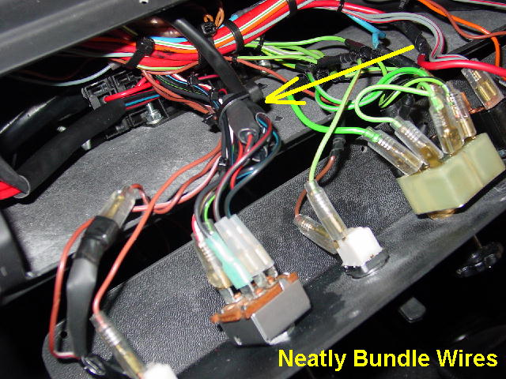
Fig. 17
- Neatly zip-tie the wires tighter as shown in figure 17.
- Reinstall all panels and reconnect the battery. Test the blower fan for proper functions.

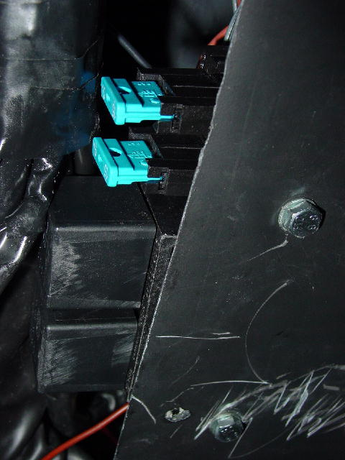

The fuses and relay will be accessible from under the dash as shown above.

